Summary

Crop | Epochs | Validation Accuracy | Test correct (out of 50) | Test Accuracy
Full Resolution | 40 | 0.92 | 49 | 0.98
60x60 – Upper Right | 40 | 0.88 | 35 | 0.70
30x30 – Upper Right | 70 | 0.82 | 39 | 0.78
10x10 – Upper Left | 120 | 0.32 | 16 | 0.32
10x10 – Lower Left | 120 | 0.54 | 22 | 0.44
10x10 – Upper Right | 120 | 0.39 | 18 | 0.36
10x10 – Lower Right | 120 | 0.48 | 19 | 0.38
10x10 – Random 1 | 120 | 0.22 | 3 | 0.06
10x10 – Random 2 | 120 | 0.27 | 3 | 0.06

Control: Full resolution
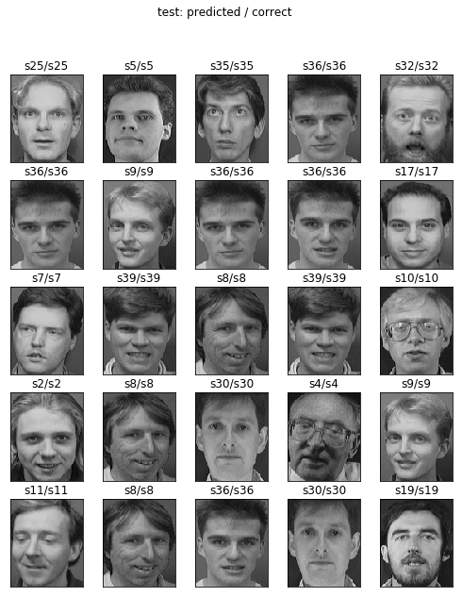
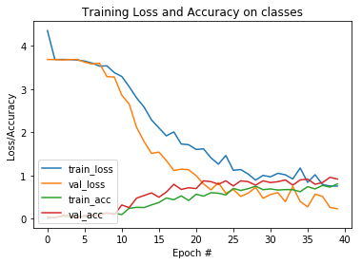
Epochs: 40
Loss on test data: 0.19890841603279114
Accuracy on test data: 0.98
Correct / Total: 49/50

Cropped: 60x60
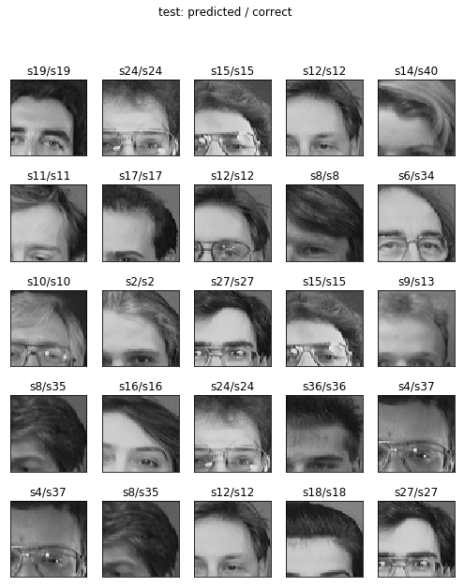
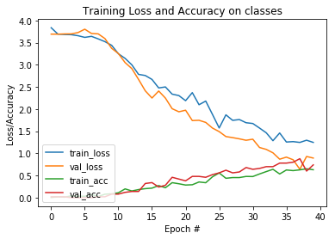

Epochs: 40
Loss on test data: 0.8803854012489318
Accuracy on test data: 0.7000000047683715
Correct / Total: 35/50

Cropped: 30x30
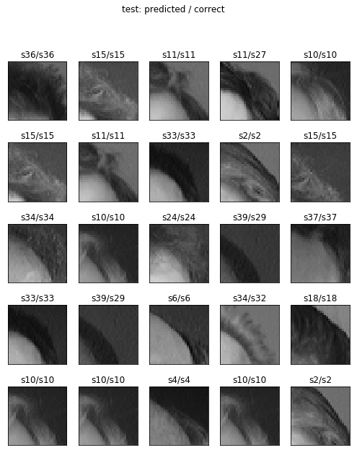
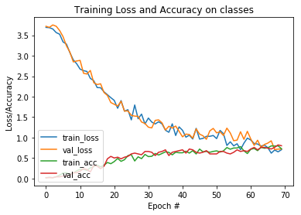

Epochs: 70
Loss on test data: 0.6761191987991333
Accuracy on test data: 0.7800000047683716
Correct / Total: 39/50

Cropped 10x10 “Upper Right”

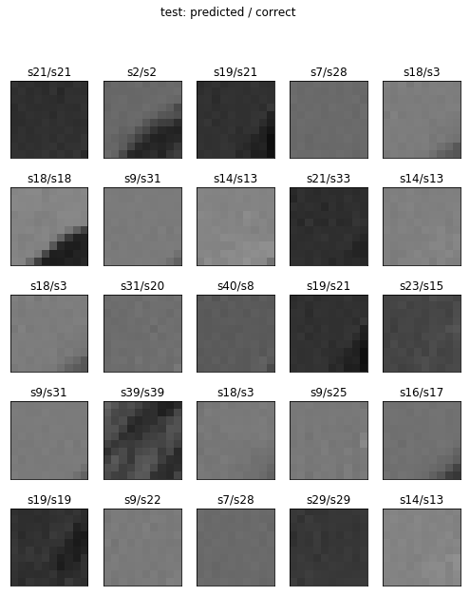
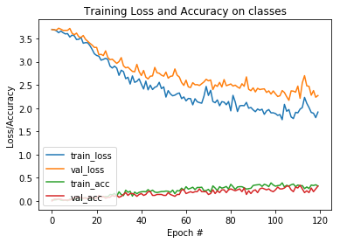

Loss on test data: 2.0545911312103273
Accuracy on test data: 0.3200000047683716
Correct / Total: 16/50

Cropper 10x10: “Lower Left”

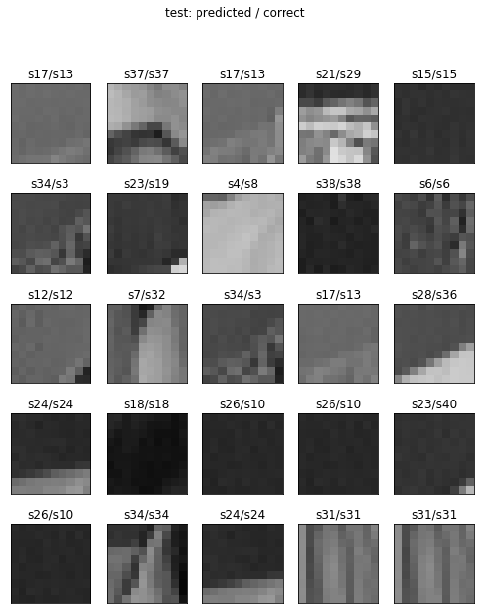

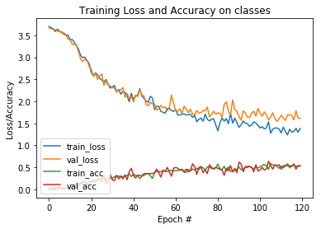

Loss on test data: 1.5678549575805665
Accuracy on test data: 0.4400000095367432
Correct / Total: 22/50

